# H5 – Testing two resampling methods or classifiers for solving class imbalance problems

**Introduction**

Class imbalance is a serious and real problem in Machine Learning. For solving these kind of problems, two solutions are proposed, resampling methods and classifiers. In this homework, two different Resampling methods are used with a CostSensitiveClassifier.

**Development & Results**

*Resample with CostSensitiveClassifier and LMT*

The first step was using the Resample Method in Weka with the original dataset of Training.csv

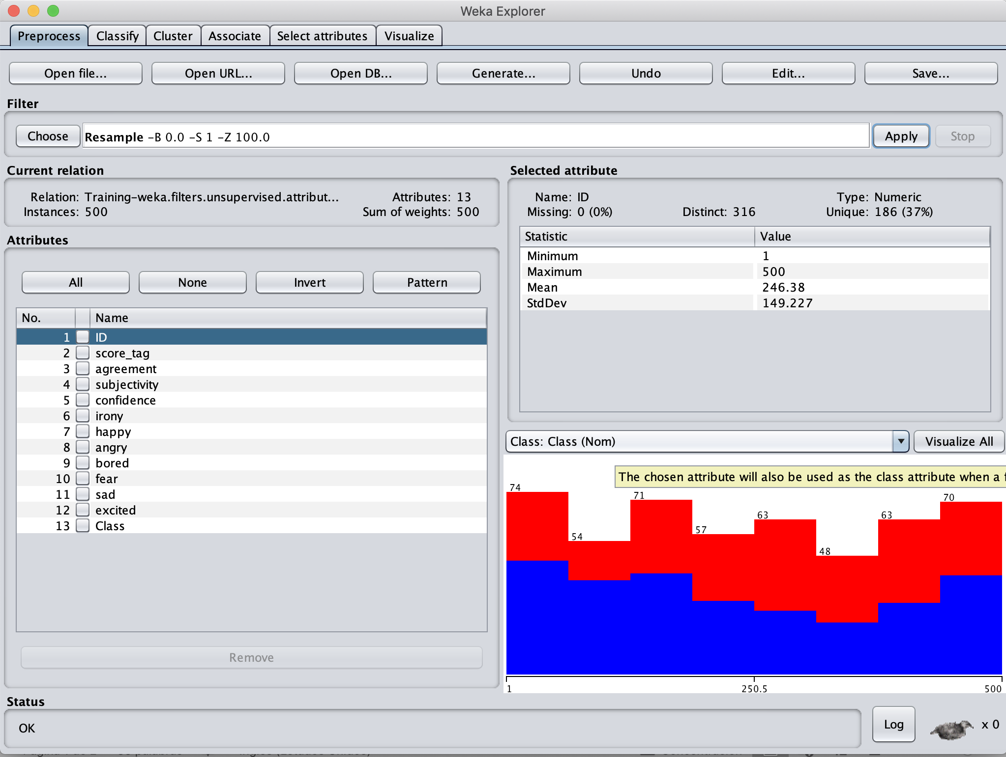

*Figure 1. Resampling Training.csv in WEKA*

Then, a CostSensitiveClassifier was applied with an LMT.

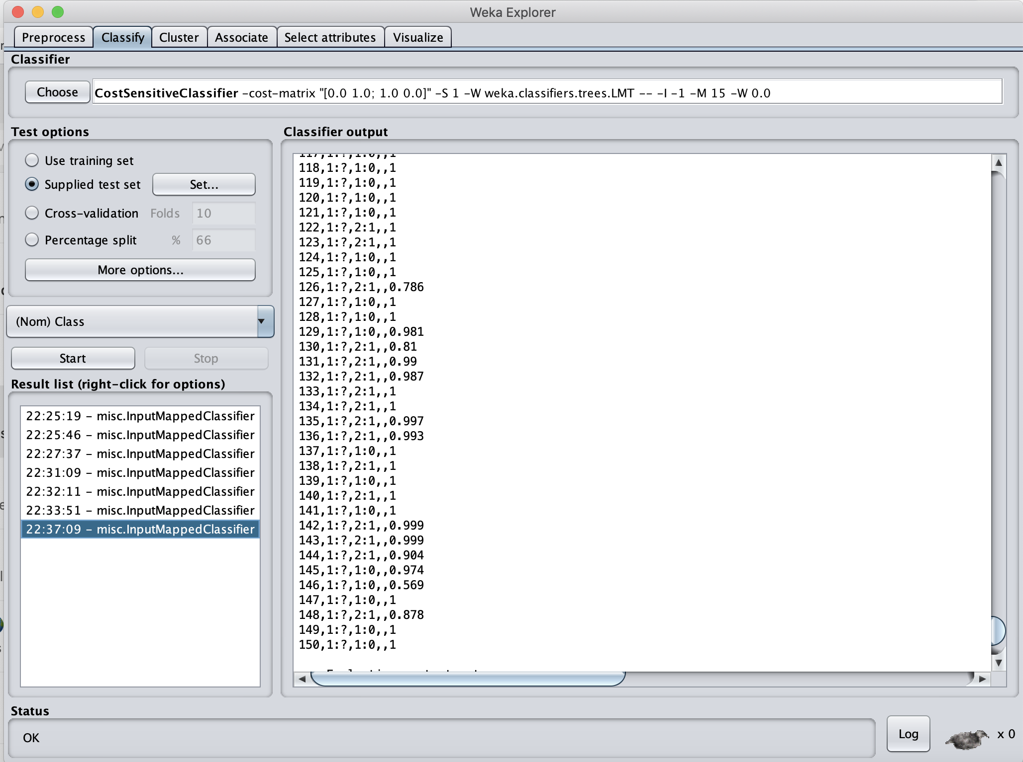

*Figure 2. Results of the LMT in WEKA*

After uploading the WEKA’s Output to Kaggle, it can be appreciated that sadly it did not scored better than by highest score.

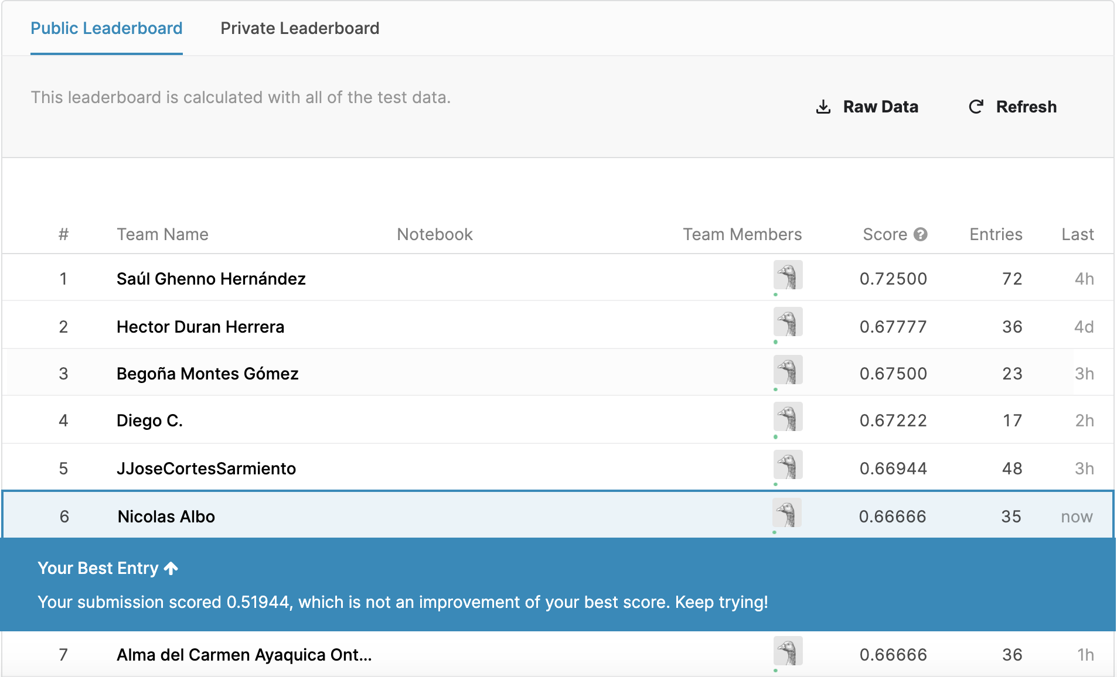

*Figure 3. Score in Kaggle*

*SpreadSubsample with CostSensitiveClassifier and LMT*

In this case, the first step was using the SpreadSubsample Method in Weka with the original dataset of Training.csv

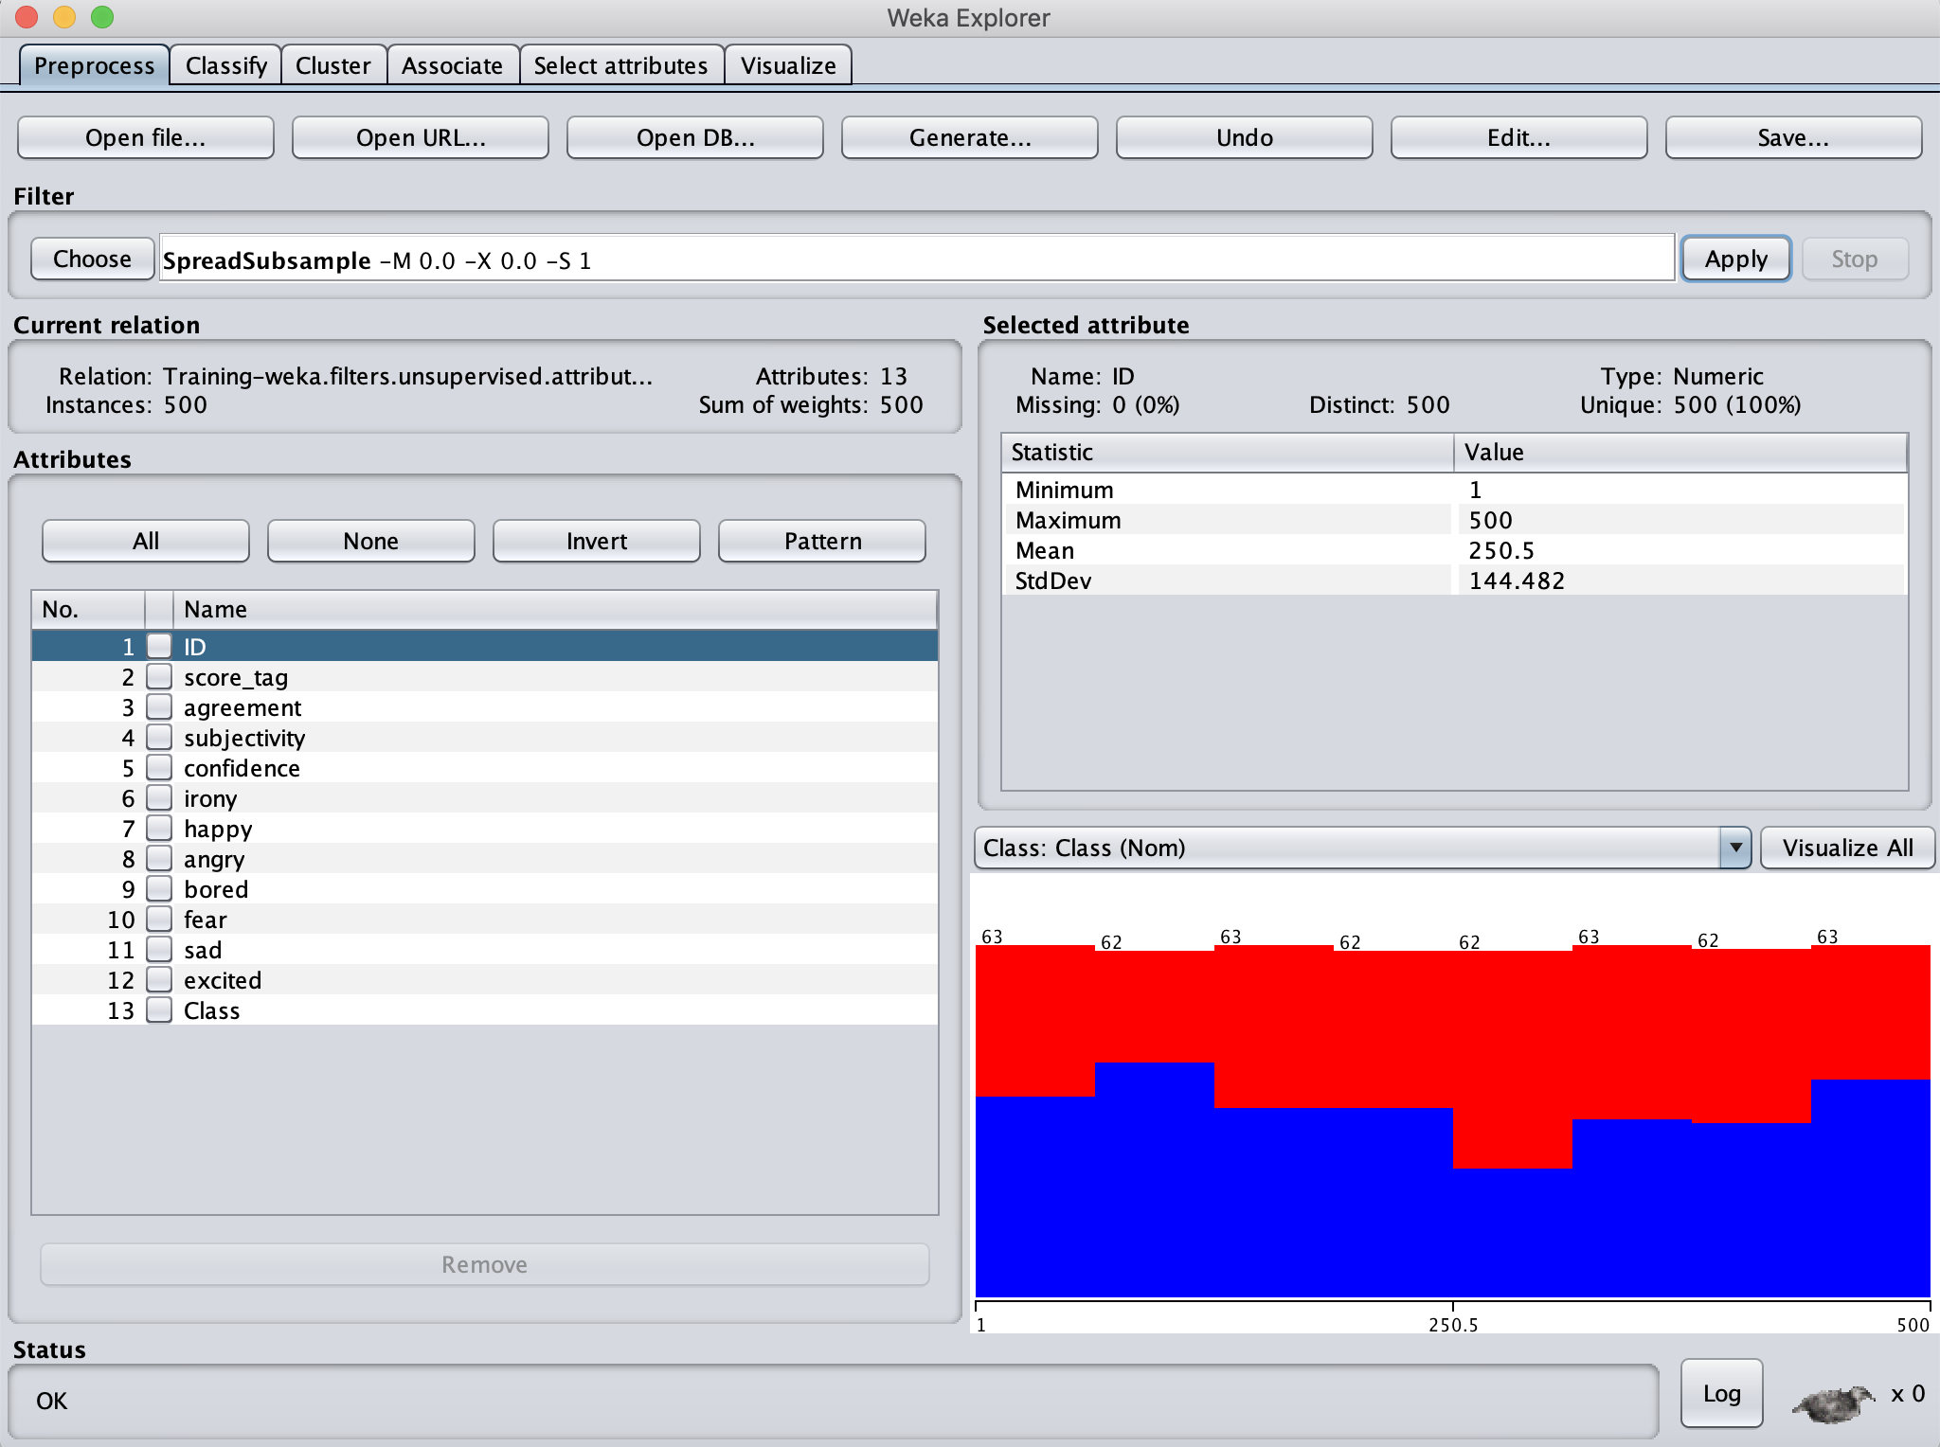

*Figure 4. SpreadSubsample method applied in Training.csv in WEKA*

Then, a CostSensitiveClassifier was applied with an LMT.

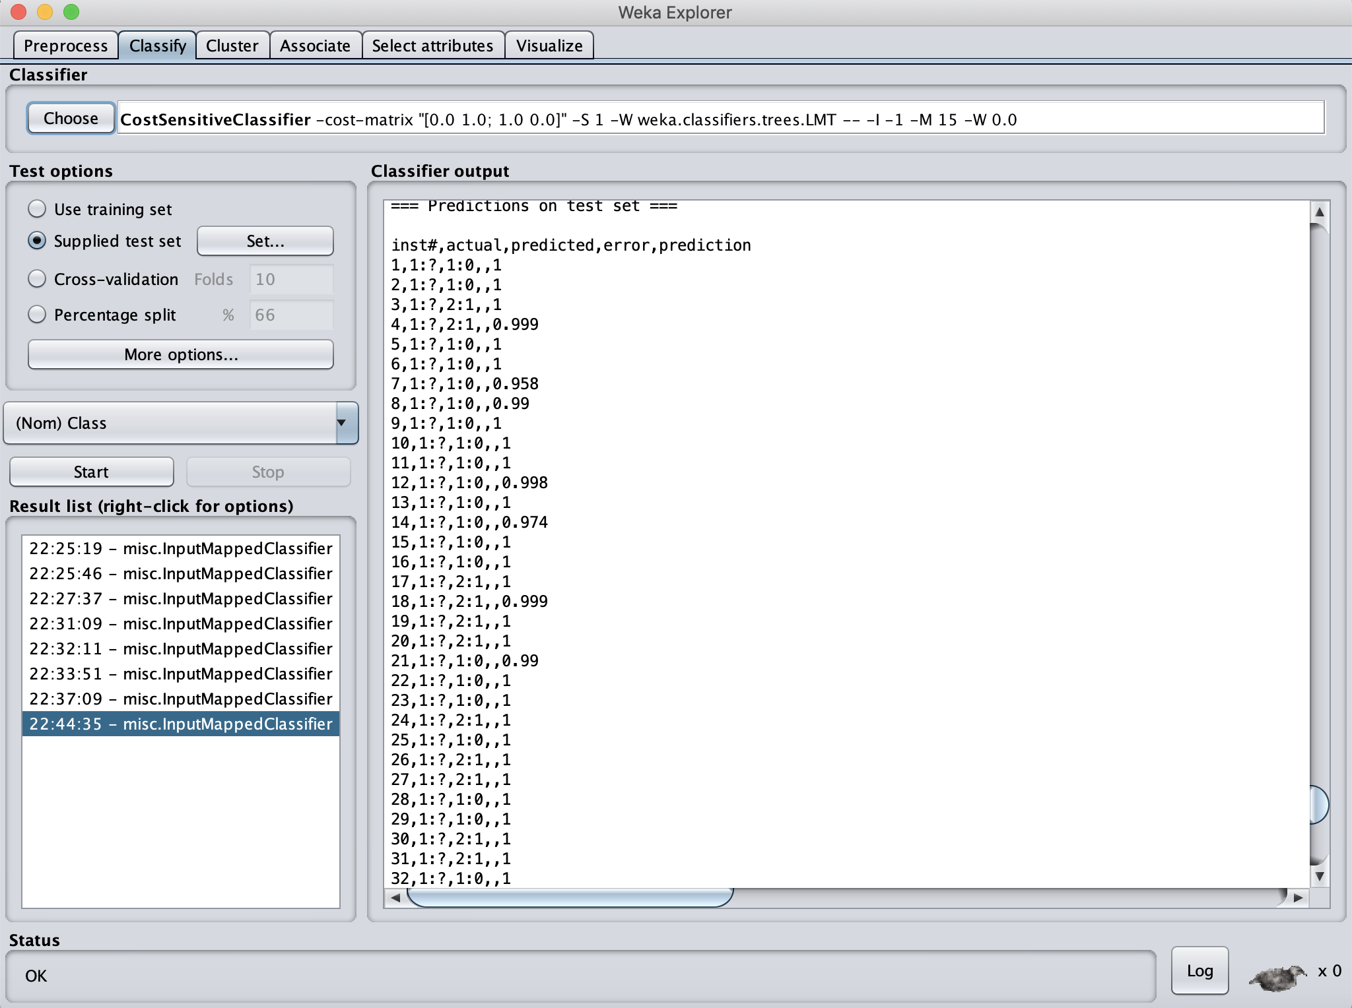

*Figure 5. Results of the LMT in WEKA*

After uploading the WEKA’s Output to Kaggle, it can be appreciated that sadly it did not scored better than by highest score.

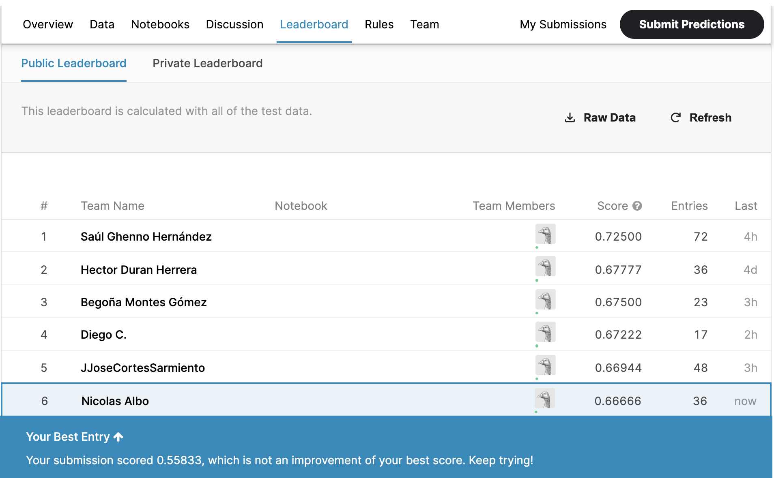

*Figure 6. Score in Kaggle*

*Resample with CostSensitiveClassifier and Hoeffding Tree*

In this last example, the first step was using the Resample Method in Weka with the original dataset of Training.csv

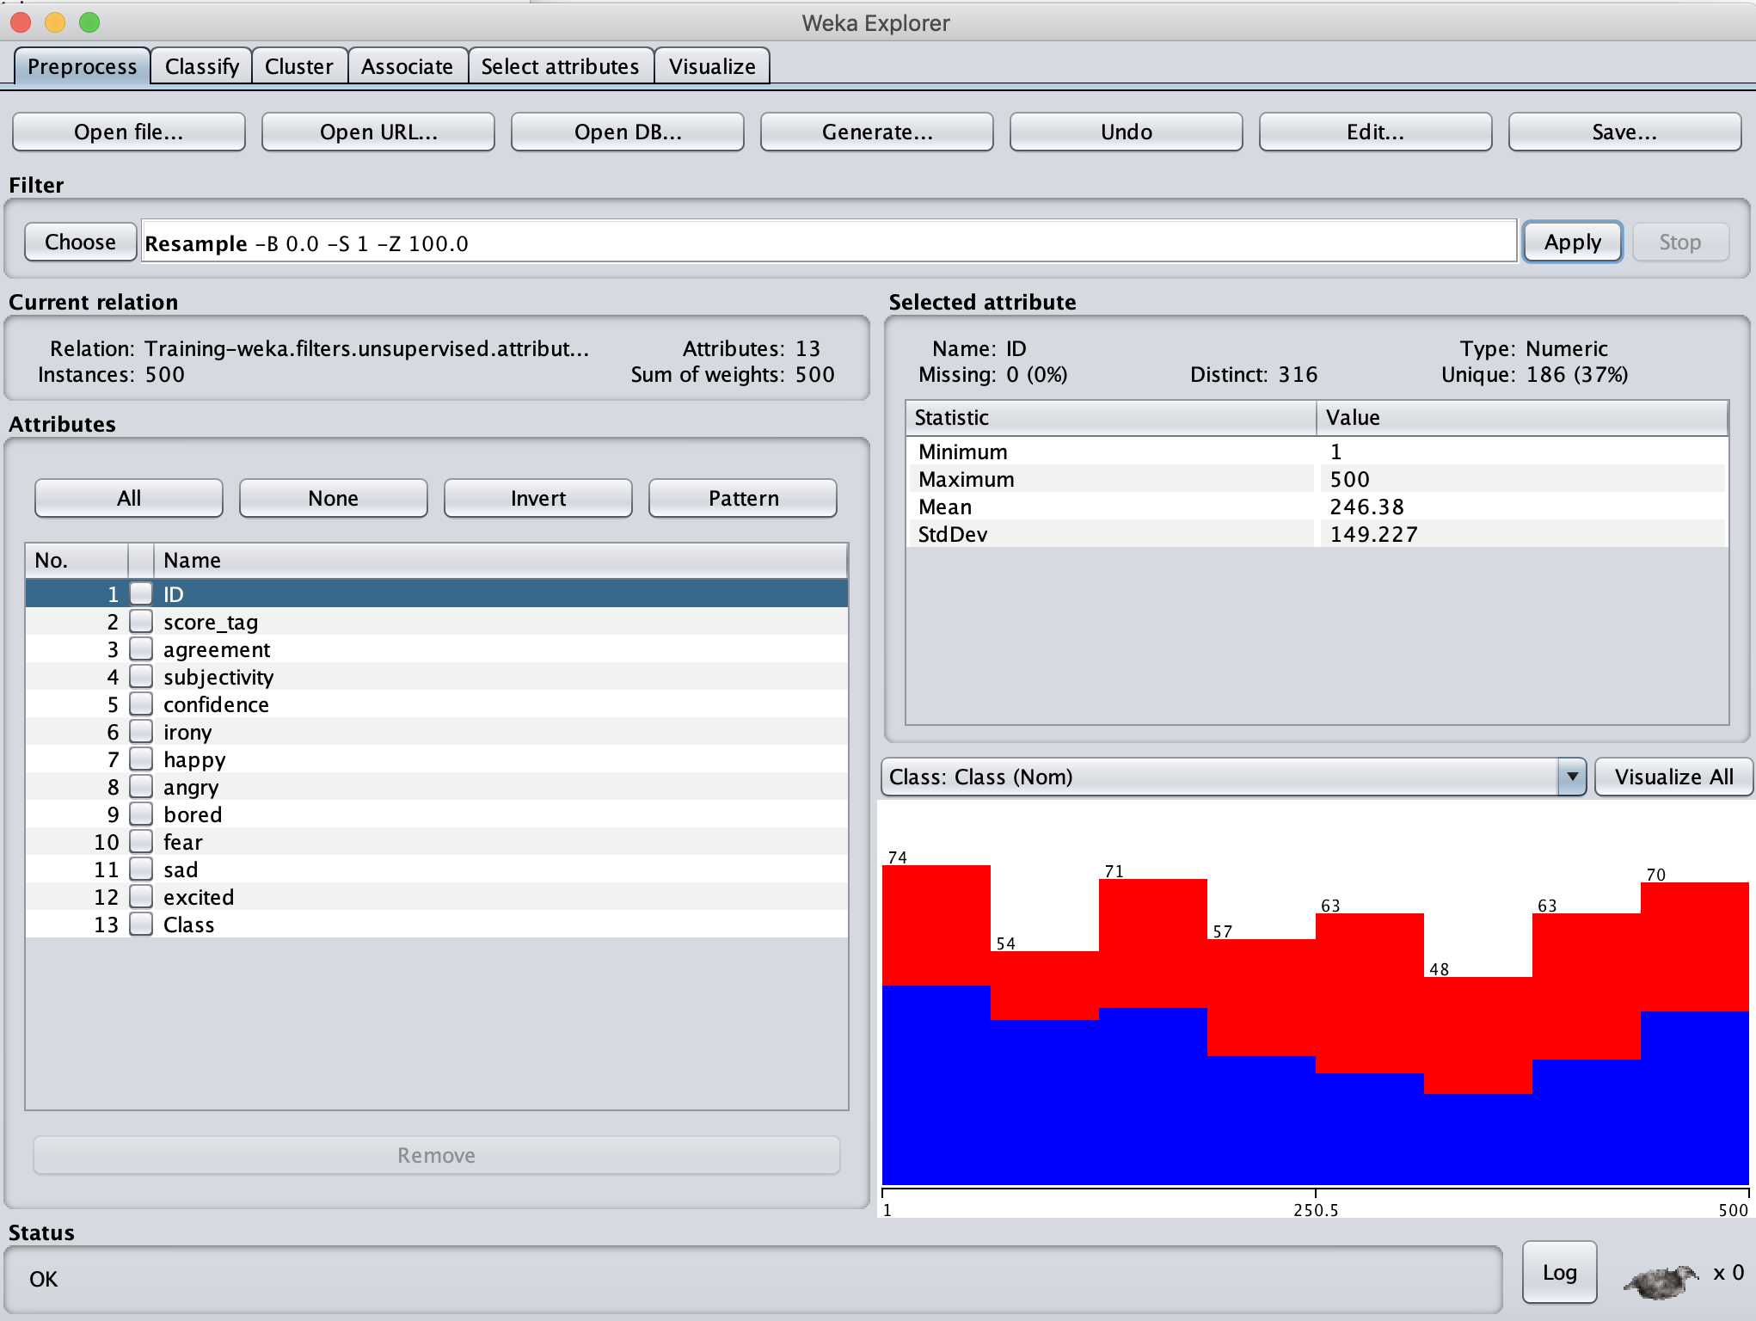

*Figure 7. Resampling Training.csv in WEKA*

Then, a CostSensitiveClassifier was applied with a Hoeffding Tree.

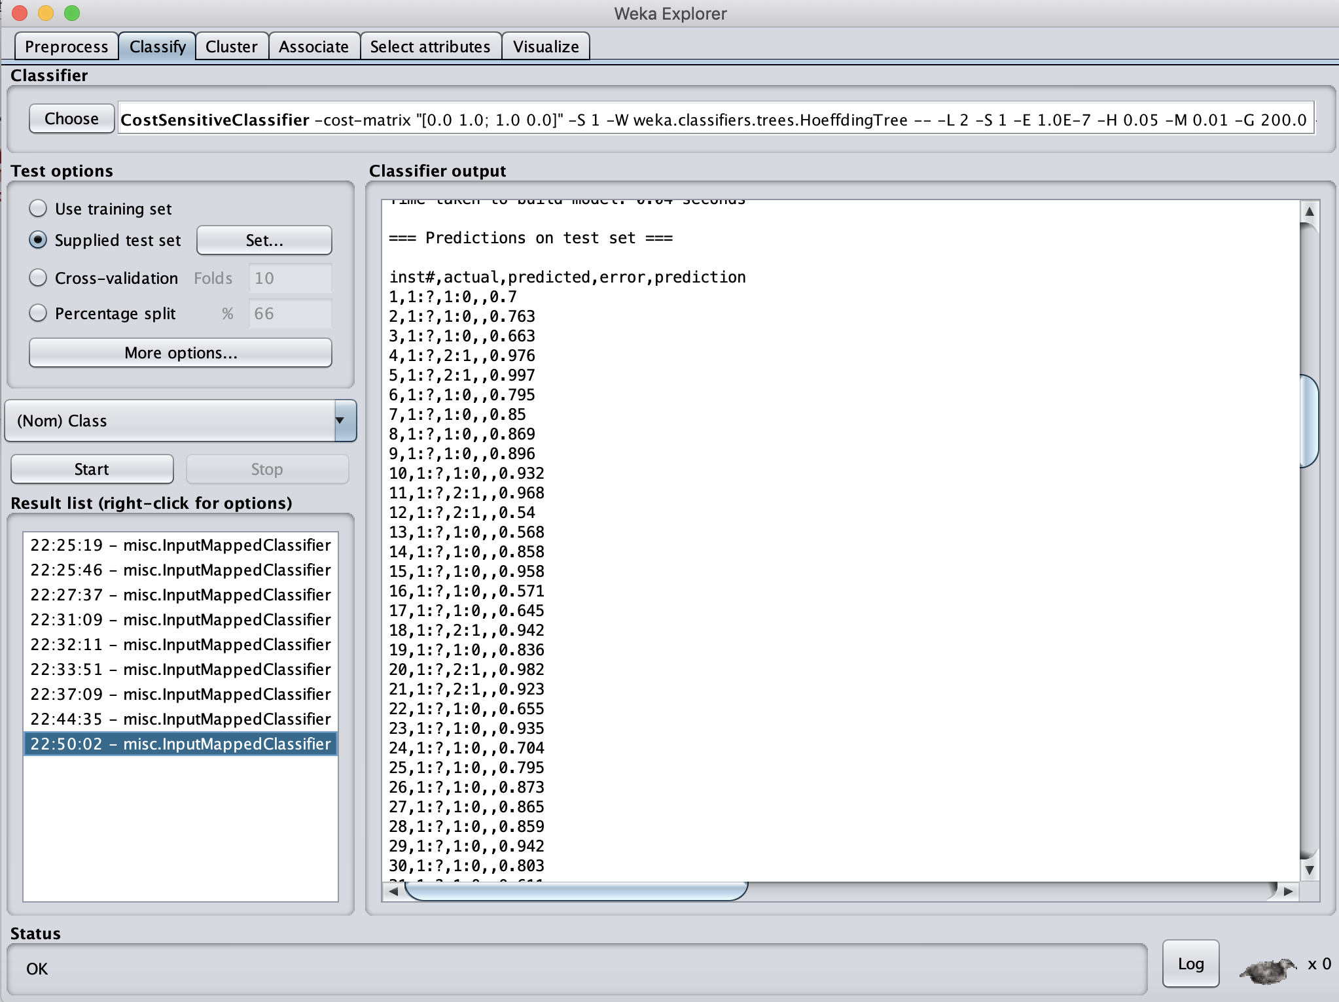

*Figure 8. Results of the Hoeffding Tree in WEKA*

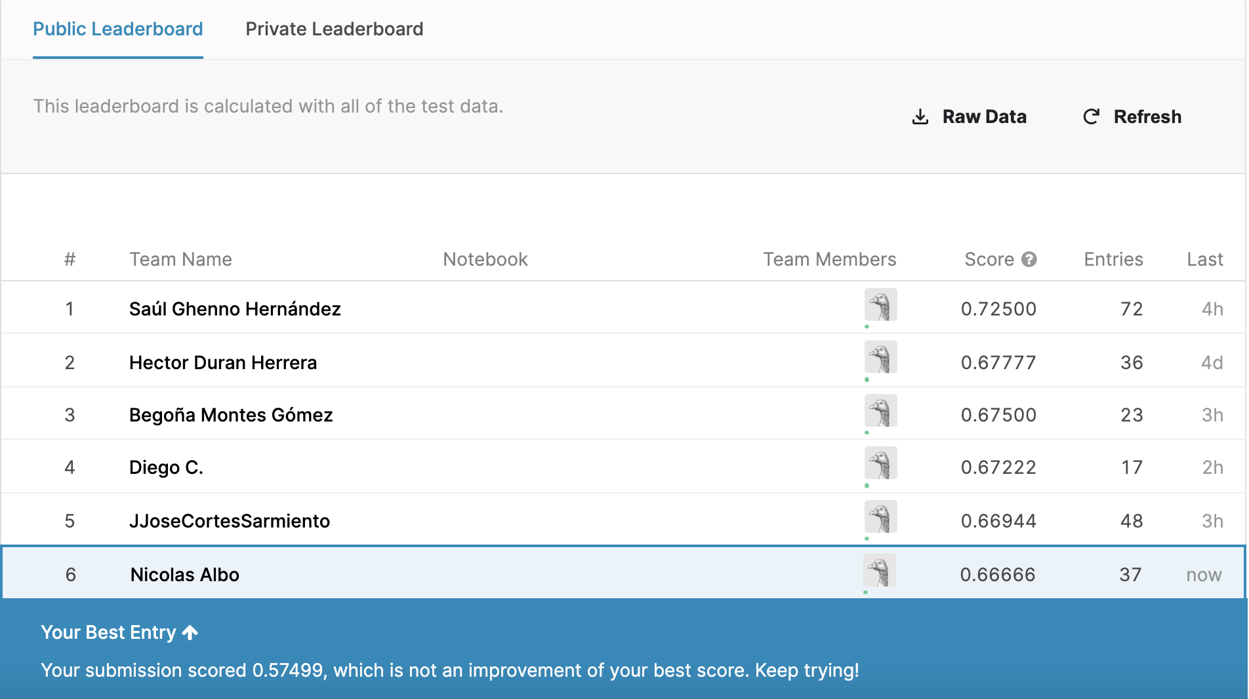

*Figure 9. Score in Kaggle*

**Conclusion**

Resampling methods or classifiers are a proper solution for class imbalance problems. But, in this case, these methods did not help me to improve my high score in Kaggle. Maybe I did not use an appropriate resampling method that could have helped me to rank higher in Kaggle.